Skill 10 – Lesson 05

Change Static NAT to Dynamic NAT on Cafe01-RT01 Only
Beginner CCNA Packet Tracer Lab - Fallout-RT01 remains an inside LAN router
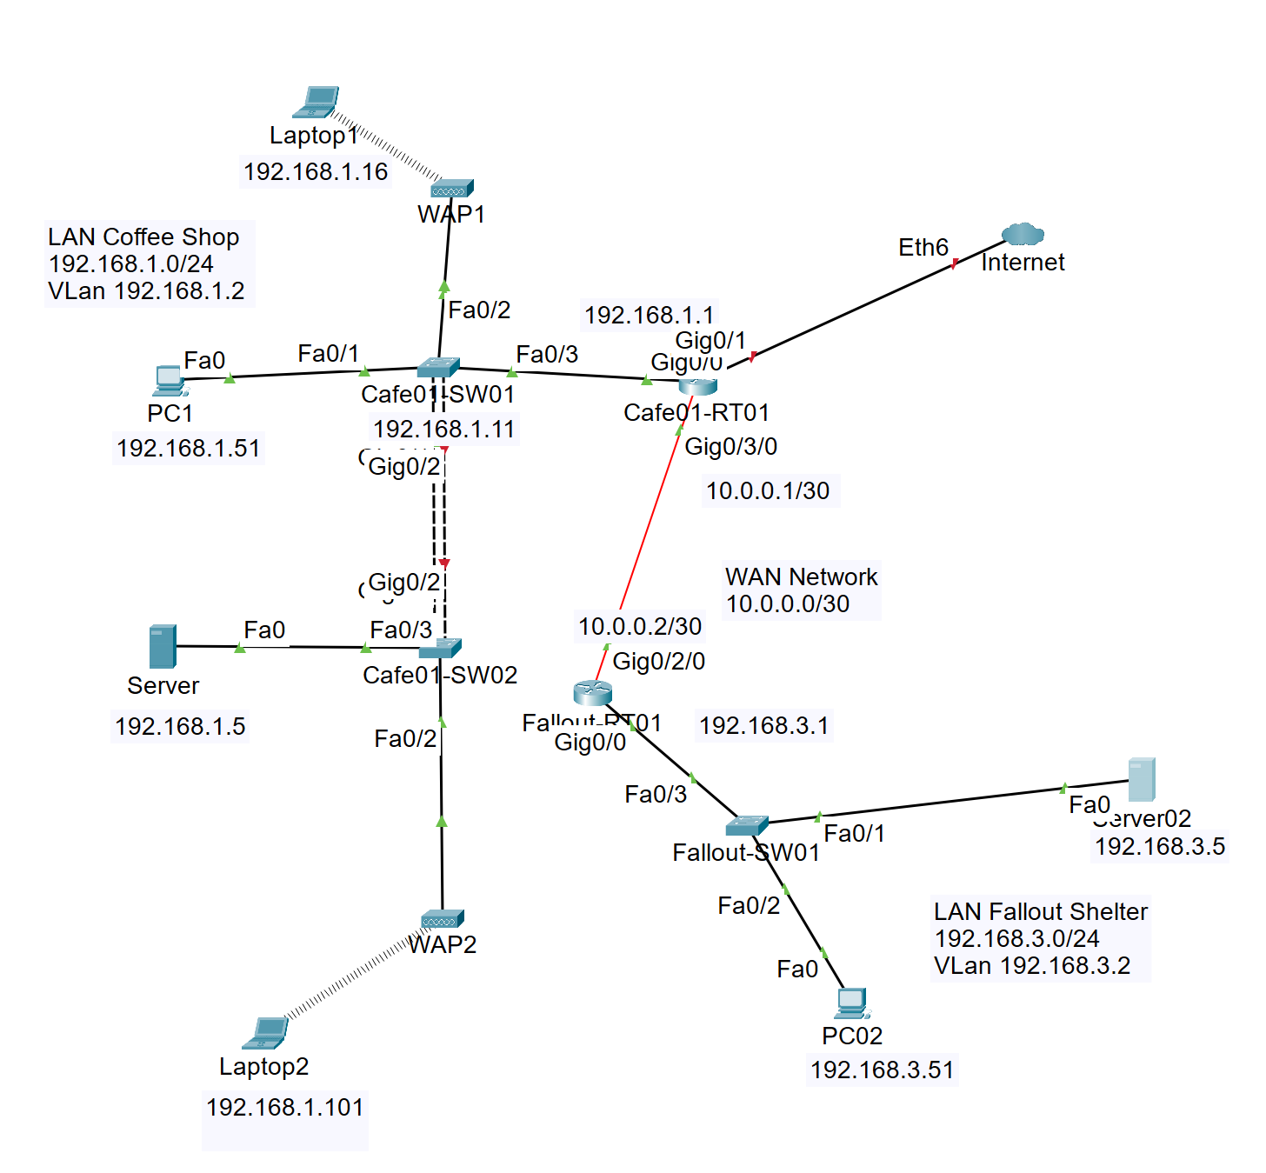
Figure 1. Network Coffee Shop and Fallout Shelter topology used for this lab. NAT is configured only on Cafe01-RT01 because it is the edge router connected to the Internet.
Corrected design: Only Cafe01-RT01 is converted from Static NAT to Dynamic NAT. Fallout-RT01 is not configured for NAT. It remains an inside router behind Cafe01-RT01, and it uses routing to reach the Internet through Cafe01-RT01.

Learning objectives
- Identify why Cafe01-RT01 is the only NAT edge router in this topology.
- Remove old Static NAT statements from Cafe01-RT01 safely.
- Configure Dynamic NAT on Cafe01-RT01 using a NAT pool and an ACL.
- Mark both internal-facing paths on Cafe01-RT01 as NAT inside when needed.
- Leave Fallout-RT01 as an inside LAN router with routing only.
- Verify NAT translations, NAT statistics, routes, and end-to-end connectivity.
- Practice removing Dynamic NAT and static routes using the no form of commands.
Vocabulary correction: The topic is NAT, not NAS. NAT means Network Address Translation. NAS usually means Network Attached Storage.

1. Topology and baseline addressing
This lab starts from the uploaded static-routing topology. The baseline network has two internal LANs and a WAN link between the routers. Cafe01-RT01 also has an Internet-facing interface, so it becomes the only NAT router.
Table 1. Baseline addressing and NAT roles.
Area | Device / interface | Address / mask | Role in this NAT lab
Coffee Shop LAN | PC1 | 192.168.1.51 /24 | Internal host; default gateway 192.168.1.1
Coffee Shop LAN | Server | 192.168.1.5 /24 | Internal server; default gateway 192.168.1.1
Coffee Shop LAN | Cafe01-RT01 LAN | 192.168.1.1 /24 | NAT inside interface for Coffee Shop LAN
Router-to-router WAN | Cafe01-RT01 to Fallout-RT01 | 10.0.0.1 /30 | Internal path toward Fallout; mark NAT inside if Fallout must reach Internet
Router-to-router WAN | Fallout-RT01 to Cafe01-RT01 | 10.0.0.2 /30 | Fallout WAN interface; no NAT configured here
Fallout Shelter LAN | Fallout-RT01 LAN | 192.168.3.1 /24 | Inside gateway for Fallout LAN; no NAT configured here
Fallout Shelter LAN | PC02 | 192.168.3.51 /24 | Internal host; default gateway 192.168.3.1
Internet side | Cafe01-RT01 Internet interface | Example: 216.0.5.2 /30 | NAT outside interface toward ISP/Internet

Interface names may differ: Your Packet Tracer router may use GigabitEthernet0/0, GigabitEthernet0/1, GigabitEthernet0/3/0, Ethernet6, or another name. Always confirm with show ip interface brief before typing interface commands.

2. NAT design: only Cafe01-RT01 translates traffic
Table 2. NAT responsibility by device.
Device | NAT role | What to configure
Cafe01-RT01 | Edge NAT router | Remove Static NAT, configure Dynamic NAT, mark inside/outside interfaces, keep routes.
Fallout-RT01 | Inside router only | Do not configure NAT. Keep/adjust routing so Fallout LAN sends Internet traffic to Cafe01-RT01.
Coffee Shop LAN hosts | Inside local hosts | Use 192.168.1.1 as default gateway.
Fallout LAN hosts | Inside local hosts behind Fallout-RT01 | Use 192.168.3.1 as default gateway. Fallout-RT01 forwards unknown traffic to Cafe01-RT01.
ISP/Internet side | Outside network | Provides next-hop route and, if using a NAT pool, return routes back to Cafe01-RT01.

Table 3. Cafe01-RT01 NAT inside and outside placement.
Cafe01-RT01 interface direction | Example interface | NAT command | Why
Coffee Shop LAN-facing | G0/0 or G0/1 | ip nat inside | Traffic from 192.168.1.0/24 enters here before going to the Internet.
Fallout-facing WAN | G0/3/0 | ip nat inside | Traffic from 192.168.3.0/24 enters Cafe01-RT01 here before going to the Internet.
Internet-facing | Eth6 or Internet port | ip nat outside | Translated traffic exits here toward the ISP/Internet.

Why the Fallout-facing interface is NAT inside: From the view of Cafe01-RT01, Fallout LAN traffic enters on the 10.0.0.1/30 link and exits toward the Internet. That makes the Fallout-facing interface an inside NAT interface on Cafe01-RT01. Fallout-RT01 itself still has no NAT commands.

Task 1 - Verify baseline routing first
Do not troubleshoot NAT until basic routing works. Use the original static-routing baseline to verify LAN and WAN connectivity.
Router baseline verification
! On Cafe01-RT01
show ip interface brief
show ip route
show running-config | include ip route
ping 10.0.0.2
! On Fallout-RT01
show ip interface brief
show ip route
show running-config | include ip route
ping 10.0.0.1

End-device baseline verification
! From PC1 command prompt
ipconfig
ping 192.168.1.1
ping 10.0.0.1
ping 10.0.0.2
ping 192.168.3.51
! From PC02 command prompt
ipconfig
ping 192.168.3.1
ping 10.0.0.2
ping 10.0.0.1
ping 192.168.1.51

Previous troubleshooting lesson: If PC1 can ping 10.0.0.1 but not 10.0.0.2, Cafe01-RT01 is reachable but the router-to-router path or return route is not correct. Check Fallout-RT01 G0/2/0 and its route back to 192.168.1.0/24.

Task 2 - Keep routing correct before NAT conversion
For Internet access, Cafe01-RT01 needs a default route to the ISP. Fallout-RT01 should point unknown traffic to Cafe01-RT01 because Fallout is an inside router.
Cafe01-RT01 routing needed for this NAT lab
! Cafe01-RT01 keeps a route back to Fallout LAN
ip route 192.168.3.0 255.255.255.0 10.0.0.2
! Cafe01-RT01 also needs a default route to the ISP/Internet
! Replace 216.0.5.1 with your real ISP next-hop if different.
ip route 0.0.0.0 0.0.0.0 216.0.5.1

Fallout-RT01 routing only - no NAT commands
! Fallout-RT01 remains an inside router.
! Use a default route to send unknown traffic, including Internet traffic, to Cafe01-RT01.
ip route 0.0.0.0 0.0.0.0 10.0.0.1
! Optional if you prefer a specific route for the Coffee Shop LAN:
ip route 192.168.1.0 255.255.255.0 10.0.0.1

Static route versus Static NAT: Static route commands begin with ip route. Static NAT commands begin with ip nat inside source static. They are different features. Removing Static NAT does not remove static routes.

Task 3 - Find and remove old Static NAT on Cafe01-RT01
Do this only on Cafe01-RT01. Fallout-RT01 should not be converted to NAT in this corrected design.
Find old Static NAT commands
! On Cafe01-RT01
show running-config | include ip nat inside source static
show running-config | include ip nat

Remove exact lines: The examples below may not match your file exactly. Use the exact IP addresses shown by your running configuration and put no in front of the command.

Cafe01-RT01: remove Static NAT entries
enable
configure terminal
! Examples only - remove each old one-to-one Static NAT entry found on Cafe01-RT01.
no ip nat inside source static 192.168.1.51 216.0.5.20
no ip nat inside source static 192.168.1.5 216.0.5.21
end
clear ip nat translation *
show running-config | include ip nat inside source static

Task 4 - Configure Cafe01-RT01 NAT inside and outside interfaces
The exact interface numbers depend on your Packet Tracer router. The command logic is the important part: LAN and Fallout-facing links are NAT inside; Internet-facing link is NAT outside.
Find the correct interfaces
! Confirm interface names and addresses first
show ip interface brief

Cafe01-RT01: NAT zone configuration
enable
configure terminal
! Coffee Shop LAN side - NAT inside
interface gigabitethernet0/0
description Coffee Shop LAN - NAT inside
ip nat inside
no shutdown
exit
! Fallout side - also NAT inside because Fallout is an internal network behind Cafe01-RT01
interface gigabitethernet0/3/0
description WAN to Fallout-RT01 - NAT inside
ip nat inside
no shutdown
exit
! Internet side - NAT outside
! Replace ethernet6 with your actual Internet-facing interface name.
interface ethernet6
description To ISP / Internet - NAT outside
ip nat outside
no shutdown
exit
end
copy running-config startup-config

Task 5 - Configure Dynamic NAT on Cafe01-RT01
Dynamic NAT requires three parts: an ACL to identify inside local addresses, a pool of inside global addresses, and a command that connects the ACL to the pool.
Table 4. Dynamic NAT address plan.
NAT item | Example used in this lab | Meaning
Inside local networks | 192.168.1.0/24 and 192.168.3.0/24 | Private internal networks that need Internet access.
Inside global pool | 216.0.5.20 - 216.0.5.21 | Public addresses temporarily borrowed by internal hosts.
Outside global targets | 1.1.1.1 and 8.8.8.8 | Simulated Internet destinations used for ping tests.

Cafe01-RT01: Dynamic NAT configuration
enable
configure terminal
! 1) Match both inside networks.
! Standard ACL 10 matches source addresses only.
access-list 10 permit 192.168.1.0 0.0.0.255
access-list 10 permit 192.168.3.0 0.0.0.255
! 2) Create a Dynamic NAT pool.
! Replace these public addresses with the pool assigned by your lab or ISP.
ip nat pool CAFE_DYN_POOL 216.0.5.20 216.0.5.21 netmask 255.255.255.0
! 3) Connect ACL 10 to the NAT pool.
ip nat inside source list 10 pool CAFE_DYN_POOL
end
copy running-config startup-config

Pool size warning: This example pool has only two addresses. That means only two inside hosts can use Dynamic NAT at the same time. If a third host tries while both addresses are in use, translation can fail until one address is free.

Task 6 - Make sure the ISP can return traffic to the NAT pool
The NAT pool addresses are not directly configured on the Cafe01-RT01 interface. The ISP side must know that 216.0.5.20 and 216.0.5.21 are reachable through Cafe01-RT01.
ISP return routes for Cafe01-RT01 Dynamic NAT pool
! On the ISP router or simulated Internet router, if your lab uses one:
ip route 216.0.5.20 255.255.255.255 216.0.5.2
ip route 216.0.5.21 255.255.255.255 216.0.5.2
! If your outside interface or next hop uses different addresses,
! replace 216.0.5.2 with Cafe01-RT01's actual Internet-facing IP.

If you use Packet Tracer cloud only: Some beginner files use a simple cloud instead of a real ISP router. If you do not have an ISP router, focus your verification on PC pings and show ip nat translations on Cafe01-RT01.

Task 7 - Verify Dynamic NAT from the Coffee Shop LAN
Generate traffic from a PC: Do not test Dynamic NAT by pinging from Cafe01-RT01 itself. NAT is created when traffic passes through the router from inside to outside.

Verify NAT for Coffee Shop LAN hosts
! On Cafe01-RT01, clear old temporary translations first.
clear ip nat translation *
! From PC1 command prompt:
ping 1.1.1.1
ping 8.8.8.8
! Immediately on Cafe01-RT01:
show ip nat translations
show ip nat statistics
show access-lists 10
show running-config | include ip nat
show ip route 0.0.0.0

Expected example for PC1 after pinging 1.1.1.1
Pro Inside global Inside local Outside local Outside global
icmp 216.0.5.20:1 192.168.1.51:1 1.1.1.1:1 1.1.1.1:1

Task 8 - Verify Dynamic NAT from the Fallout LAN
Fallout-RT01 still has no NAT commands. PC02 traffic travels from the Fallout LAN to Fallout-RT01, then to Cafe01-RT01, then Cafe01-RT01 performs NAT out to the Internet.
Verify NAT for Fallout LAN hosts through Cafe01-RT01
! On Fallout-RT01, verify it has a default route toward Cafe01-RT01.
show ip route
show running-config | include ip route
! From PC02 command prompt:
ping 192.168.3.1
ping 10.0.0.1
ping 1.1.1.1
ping 8.8.8.8
! Immediately on Cafe01-RT01:
show ip nat translations
show ip nat statistics
show access-lists 10

Expected example for PC02 after pinging 8.8.8.8
Pro Inside global Inside local Outside local Outside global
icmp 216.0.5.21:1 192.168.3.51:1 8.8.8.8:1 8.8.8.8:1

Task 9 - Troubleshooting checklist
- If PC1 cannot ping 192.168.1.1, fix the Coffee Shop LAN before troubleshooting NAT.
- If PC02 cannot ping 192.168.3.1, fix the Fallout LAN before troubleshooting NAT.
- If PC02 can ping 192.168.3.1 but not 10.0.0.1, check Fallout-RT01 route to Cafe01-RT01 and the 10.0.0.0/30 link.
- If Cafe01-RT01 cannot ping the ISP next hop, fix the Internet-facing interface or default route first.
- If show ip nat translations is empty, generate traffic from a PC and run the command immediately after the ping.
- If the ACL counter does not increase, ACL 10 is not matching the source network. Check access-list 10.
- If translations appear but pings fail, check ISP return routes to 216.0.5.20 and 216.0.5.21.
- If only two hosts work, remember the Dynamic NAT pool has only two public addresses.
- If show ip nat status fails, use show ip nat statistics instead. Packet Tracer IOS may not support show ip nat status.
Quick troubleshooting command set
! Useful commands on Cafe01-RT01
show ip interface brief
show running-config | include ip nat
show running-config | include access-list
show running-config | include ip route
show ip route
show ip nat translations
show ip nat statistics
show access-lists
clear ip nat translation *
! Useful commands on Fallout-RT01
show ip interface brief
show ip route
show running-config | include ip route
ping 10.0.0.1

Task 10 - How to remove Dynamic NAT or static routes
Remove in the correct order: Remove the NAT rule first, then the NAT pool, then the ACL. Clear translations after removing NAT.

Remove Dynamic NAT from Cafe01-RT01
! On Cafe01-RT01 - remove Dynamic NAT configuration
configure terminal
no ip nat inside source list 10 pool CAFE_DYN_POOL
no ip nat pool CAFE_DYN_POOL 216.0.5.20 216.0.5.21 netmask 255.255.255.0
no access-list 10
! Optional: remove NAT labels from interfaces if you are fully resetting the lab
interface gigabitethernet0/0
no ip nat inside
exit
interface gigabitethernet0/3/0
no ip nat inside
exit
interface ethernet6
no ip nat outside
exit
end
clear ip nat translation *
show running-config | include ip nat

Remove Static NAT entries from Cafe01-RT01
! Remove old Static NAT lines if they still exist.
! Use the exact lines shown by your running config.
configure terminal
no ip nat inside source static 192.168.1.51 216.0.5.20
no ip nat inside source static 192.168.1.5 216.0.5.21
end
show running-config | include ip nat inside source static

How to remove static routes
! Static routes are removed with no ip route.
! Remove only when they are wrong or when the lab asks for cleanup.
! On Cafe01-RT01, remove route to Fallout LAN:
configure terminal
no ip route 192.168.3.0 255.255.255.0 10.0.0.2
end
! On Cafe01-RT01, remove default route to ISP:
configure terminal
no ip route 0.0.0.0 0.0.0.0 216.0.5.1
end
! On Fallout-RT01, remove default route toward Cafe01-RT01:
configure terminal
no ip route 0.0.0.0 0.0.0.0 10.0.0.1
end

Completion checklist
- [ ] Cafe01-RT01 has no old ip nat inside source static lines unless the lab asks for Static NAT.
- [ ] Cafe01-RT01 Coffee Shop LAN interface is ip nat inside.
- [ ] Cafe01-RT01 Fallout-facing interface is ip nat inside if Fallout LAN must reach the Internet.
- [ ] Cafe01-RT01 Internet-facing interface is ip nat outside.
- [ ] Cafe01-RT01 has ACL 10 permitting 192.168.1.0/24 and 192.168.3.0/24.
- [ ] Cafe01-RT01 has NAT pool CAFE_DYN_POOL.
- [ ] Cafe01-RT01 has ip nat inside source list 10 pool CAFE_DYN_POOL.
- [ ] Cafe01-RT01 has a default route to the ISP/Internet.
- [ ] Fallout-RT01 has no NAT commands and has a route/default route toward Cafe01-RT01.
- [ ] PC1 can ping simulated Internet targets and creates NAT translations.
- [ ] PC02 can ping simulated Internet targets and creates NAT translations on Cafe01-RT01.
- [ ] All configurations are saved with copy running-config startup-config.

Student understanding questions
- Why is Cafe01-RT01 the only router configured for NAT in this corrected design?
Answer: ________________________________________________________________________________
________________________________________________________________________________
- Why should Fallout-RT01 not have ip nat inside or ip nat outside commands in this lab?
Answer: ________________________________________________________________________________
________________________________________________________________________________
- Which Cafe01-RT01 interfaces should be marked ip nat inside?
Answer: ________________________________________________________________________________
________________________________________________________________________________
- Which Cafe01-RT01 interface should be marked ip nat outside?
Answer: ________________________________________________________________________________
________________________________________________________________________________
- What command shows the old Static NAT entries before you remove them?
Answer: ________________________________________________________________________________
________________________________________________________________________________
- How do you remove an old Static NAT entry?
Answer: ________________________________________________________________________________
________________________________________________________________________________
- What does access-list 10 match in this lab?
Answer: ________________________________________________________________________________
________________________________________________________________________________
- Why can show ip nat translations be empty even after NAT is configured correctly?
Answer: ________________________________________________________________________________
________________________________________________________________________________
- Why is pinging from Cafe01-RT01 not the best Dynamic NAT test?
Answer: ________________________________________________________________________________
________________________________________________________________________________
- What command shows NAT hits, misses, inside/outside interfaces, and pool usage?
Answer: ________________________________________________________________________________
________________________________________________________________________________
- What happens if the Dynamic NAT pool has two addresses but three hosts try to use NAT at the same time?
Answer: ________________________________________________________________________________
________________________________________________________________________________
- What is the command to remove the Cafe01-RT01 static route to the Fallout LAN?
Answer: ________________________________________________________________________________
________________________________________________________________________________

Answer key
Answer key for self-check or instructor review.
Question | Answer
1 | Cafe01-RT01 is the edge router connected to the Internet, so it performs translation for internal networks.
2 | Fallout-RT01 is an internal router only. It forwards traffic to Cafe01-RT01 and does not translate addresses.
3 | The Coffee Shop LAN interface and the Fallout-facing WAN interface on Cafe01-RT01.
4 | The Cafe01-RT01 Internet-facing interface, such as Ethernet6 in the topology.
5 | show running-config | include ip nat inside source static
6 | Use the no form of the exact command, such as no ip nat inside source static 192.168.1.51 216.0.5.20.
7 | It permits source networks 192.168.1.0/24 and 192.168.3.0/24 for Dynamic NAT.
8 | Dynamic NAT entries are temporary and are created only when inside traffic passes through the router. ICMP entries may expire quickly.
9 | Router-sourced traffic does not pass from an inside interface to an outside interface, so it may not create a NAT translation.
10 | show ip nat statistics
11 | The third host may fail to translate until one of the two pool addresses becomes free.
12 | no ip route 192.168.3.0 255.255.255.0 10.0.0.2

